Meeting in the Middle (MIM)
Adolescent program – Sharing ideas and practice
“What does it look like?”

Dear fellow Montessori practitioners,
The five Western Australian Montessori Adolescent Programs (MAP) are delighted to offer you the opportunity to head out west and join us from 6 September 2018 through to 9 September 2018 to view our prepared environments and to share stories of best practise from our Australasian colleagues.
Abstract submissions are now open for the Meeting in the Middle workshops. This event is not intended as a training program but will enable those who are currently working in an Adolescent Program or those intending to commence a Montessori Adolescent Program to hear experiences and journey’s from fellow educators. This event is an ideas incubator and networking opportunity to assist you in moulding your program into best practise.
Intentions of MIM:
- Strengthening and development of MAP’s within our region
- Regular reminder of identified essential ingredients of MAP’s
- Sharing of ideals, ideas and practices
- Recognition of the diversity of contexts and programs
- Close look at prepared environment, including structures and working processes of host program(s)
- Experiences of unique local opportunities for and examples of place-based pedagogy
- Think tank to clarify goals, develop practices, tackle challenges, provide collegial mentoring
- Affordable opportunity to build connections, collaborations and networks
- Affordable opportunity for whole team reflection and planning
- Establishment and support of interschool activities

General Instructions for abstract submissions:
- Abstract submission deadline 6 April 2018
- Align presentation to the above intentions of MIM
- Presentations should be 15-20 minutes duration with a facilitated discussion
- Presentations are encouraged to have an interactive component
- Identify your preferred Workshop time and date
- Submitting an extract does not automatically register you as a speaker
- Submit abstracts as a Word document to APadmin@rms.wa.edu.au

Please indicate if you are willing to facilitate workshops and your preferred session times.

Meeting in the Middle Program Outline
Thursday 6 September 2018

4.00pm – 7.00pm Beehive Montessori School
Introduction and welcome to MIM
Overview and update of 2017 MIM projects
Tour of Adolescent Program
Drinks on the Sun Deck

7.00pm Transport to Be Fremantle accommodation

Friday 7 September 2018

8.00am Bus leaves Be Fremantle accommodation

9.00am Bus arrives at The Montessori School (Kingsley)
Tour of Adolescent Program

9.45am Morning tea

10.00am - 11.30am Workshop 1

11.30am – 1.00pm Workshop 2

1.oopm Bus leaves The Montessori School
Lunch provided on route

2.00pm Arrive at Treetops Montessori School
Tour of Adolescent Program

3.00pm – 4.30pm Workshop 3

4.45pm Bus leaves for Be Fremantle accommodation
Afternoon tea provided on route

Saturday 8 September 2018

8.00am Bus leaves Be Fremantle accommodation

9.00am Arrive at Rockingham Montessori School
Tour of Adolescent Program

9.45am Morning tea

10.00am - 11.30am Workshop 4

11.30am – 1.00pm Workshop 5

1.00pm – 2.00pm Lunch

2.00pm – 3.30pm Workshop 6

3.45pm Afternoon tea

4.15pm Bus leaves Rockingham Montessori School for Be Fremantle accommodation

6.30pm MIM Dinner and entertainment in Fremantle

Sunday 9 September 2018

8.00am Bus leaves Be Fremantle accommodation

9.00am Bus arrives at Perth Individual – A Progressive Montessori School
Tour of Adolescent Program

9.45am Morning tea

10.00am - 11.00am Workshop 7

11.00am – 12.00pm Closure of program

12.30pm Bus leaves for airport

September will be here before we know it so please book your flights and accommodation and register your attendance through APadmin@rms.wa.edu.au
To ensure you can relax and enjoy your time over in the West we have arranged transportation from the airport to and from your accommodation and between the five schools each day. To assist us with minimising travel times we recommend that you book your accommodation with Be Fremantle https://befremantle.com.au/ where we have confirmed conference rates for all participants. These apartments are centrally located a short distance from Fremantle’s Cappuccino Strip so you can stroll to the strip for breakfast or book breakfast to be delivered to your room.

Be Fremantle Accommodation
https://befremantle.com.au/

In an effort to reduce costs for participants the apartment costs listed below are based on shared rooms.
- 2 bedroom apartments have 2 queen beds, 1 can be split to x2 king singles. Therefore sleeping 3 people per each 2 bedroom apt.
- 3 bedroom apartments have 3 queen beds, 2 beds can be split to x2 king singles = x4 king single beds. Therefore sleeping 5 people per each 3 bedroom apt
Apartment Type | No. Apts | Rate
Harbour View Two Bedroom/ Two Bathroom | 3 | $285
Marina View Two Bedroom / One Bathroom | 4 | $280
Marina View Three Bedroom / Two Bathroom | 8 | $420
Breakfast @ $12 per day
Continental Breakfast Tray delivered to the Apartment on the afternoon prior so it is available first thing in the morning.

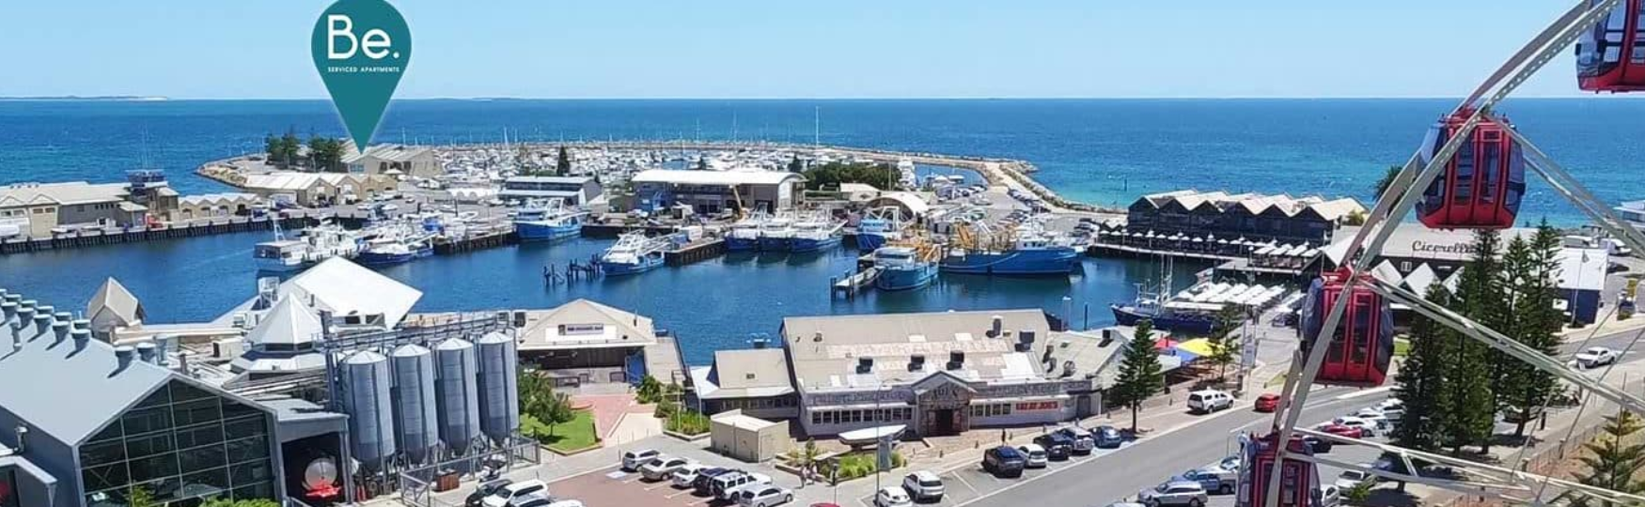

Meeting in the Middle
To register please complete both the Registration Form and Accommodation Form and return to APadmin@rms.wa.edu.au. Please finalise your registration and accommodation booking by 30 June 2018.

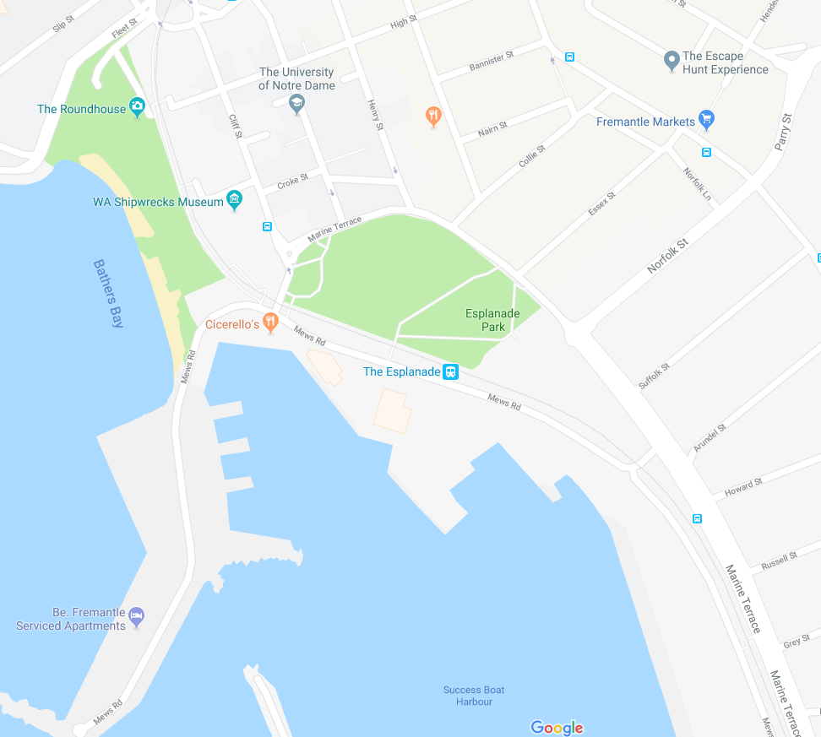
Registration Form
BeFremantle Apartments
Cappuccino Strip
Name _____________________________________
School ____________________________________
School Email _______________________________
Home Address ______________________________
__________________________ Postcode ________
Phone Home ________________________________
Phone Mobile _______________________________
Phone Work ________________________________
Email ______________________________________

Please indicate dietary requirements:
Vegetarian Gluten free Other ___________________________

Accommodation Form
Please forward your accommodation request to Apadmin@rms.wa.edu.au where will arrange shared rooms or your preferred guests for your apartment.
Guest/s name/s | Apartment Type | Breakfast delivered to room each day | Dietary requirements

Preferred guest/s for apartment: _____________________________________________________
Please tick if no preference for guest/s to share with.
Bus Booking Information
I will be utilising the complimentary bus transport between venues.
I will be utilising my own transport from the airport and between venues.

